Work Diary App v02 of 12 Aug 2018

Before you use the work diary, run the Google Browser with yourself signed in to your MIT-Google-Linked account.  
like [stu999@manukaumail.com](mailto:stu999@manukaumail.com)

Then navigate to:  
<https://manukautech.info/WorkDiary/>

Click the "Google" login button on the right.  
First time you do this you need to confirm your website registration.  
This is an example of a website re-using a membership system from another website so that users do not need new usernames and passwords for every website. Canvas does this in a similar way. You can do this too, we will be learning this later.

Then navigate to "Home" if you are not already there:  
You will see projects you can join:  
Click on the "Join this Project" link for "Full Stack Project Website"

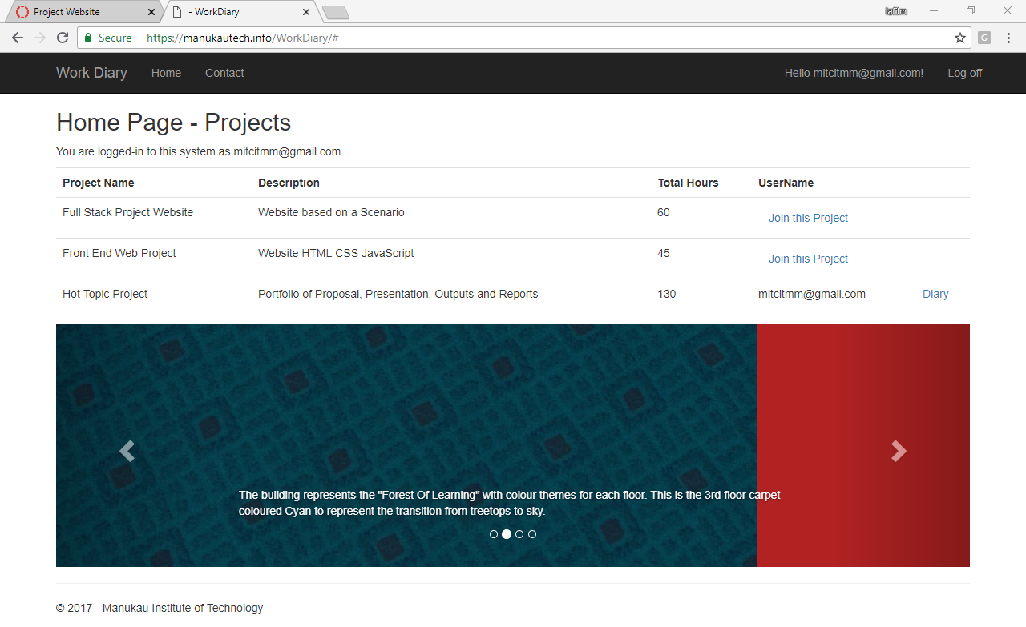

The Work Diary has a form for recording category, start time, end time and notes for each session of work.  
At the end of the course it can generate a categories metrics report for you.